**Experiment 6:** Demonstrate virtualization by Installing Type-2 Hypervisor in your device, create and configure VM image with a Host Operating system (Either Windows/Linux).

Step 1: Creating a New File.

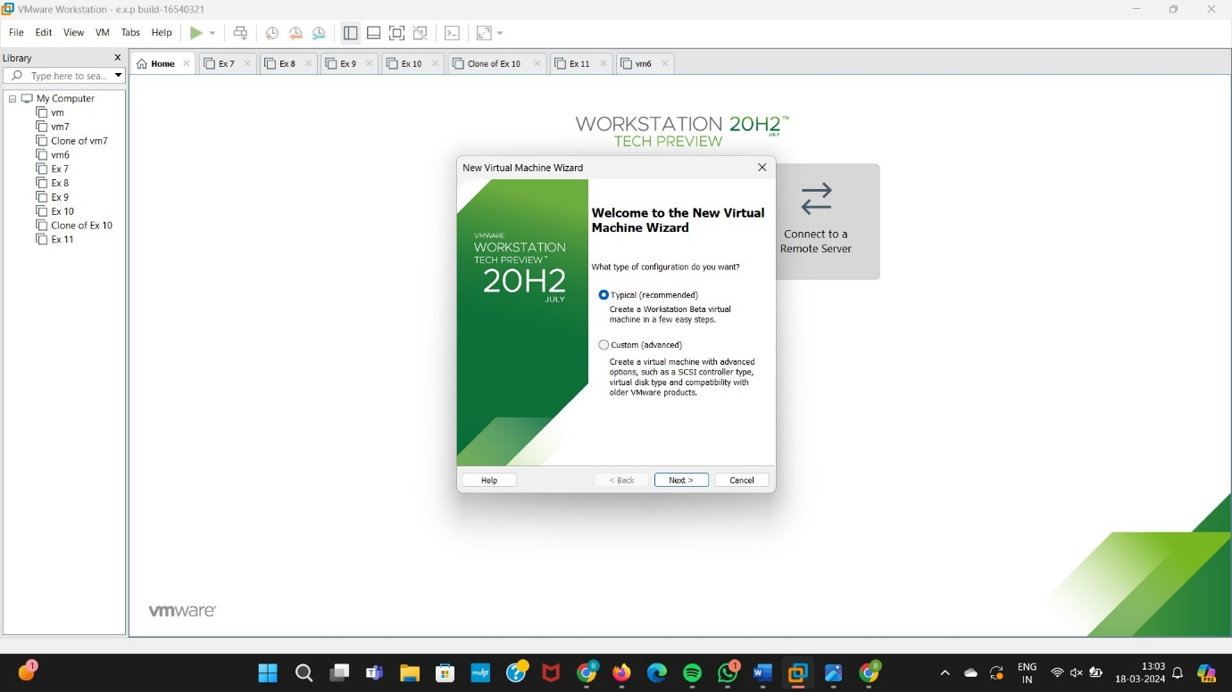

Step 2: We need to go for the ISO Guest Operating System.

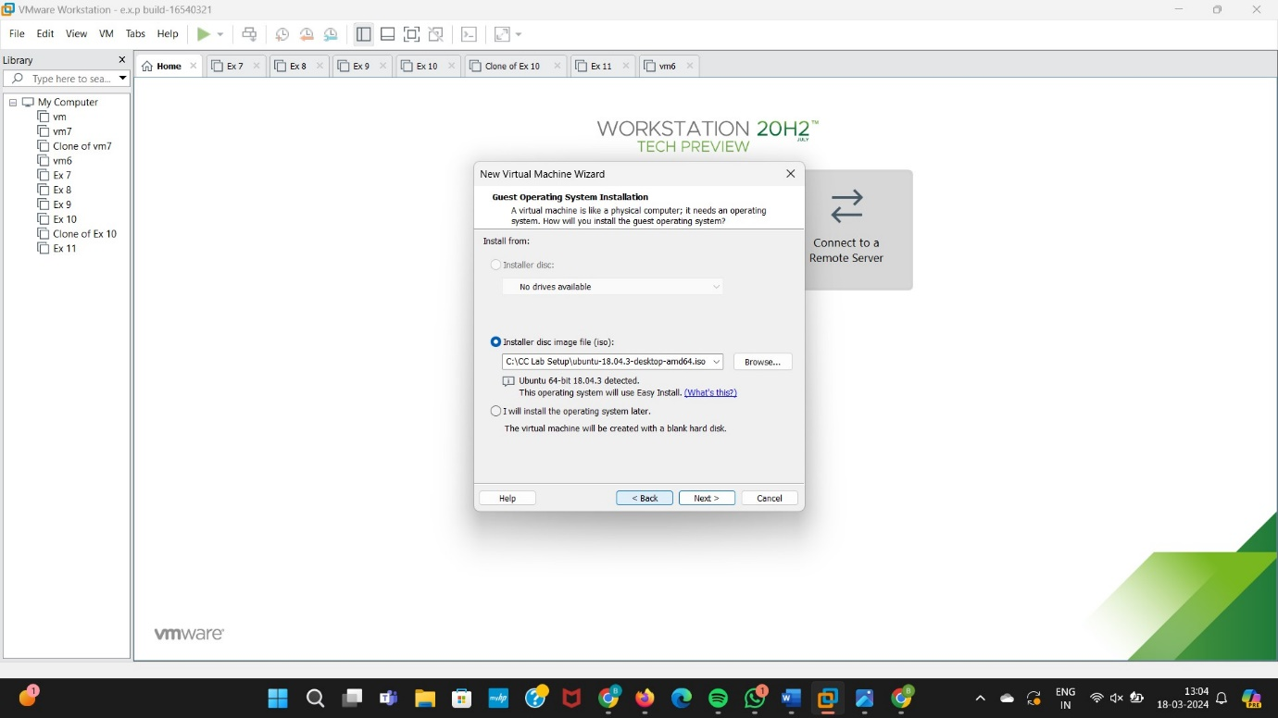

Step 3: Enter the Personalise linux.

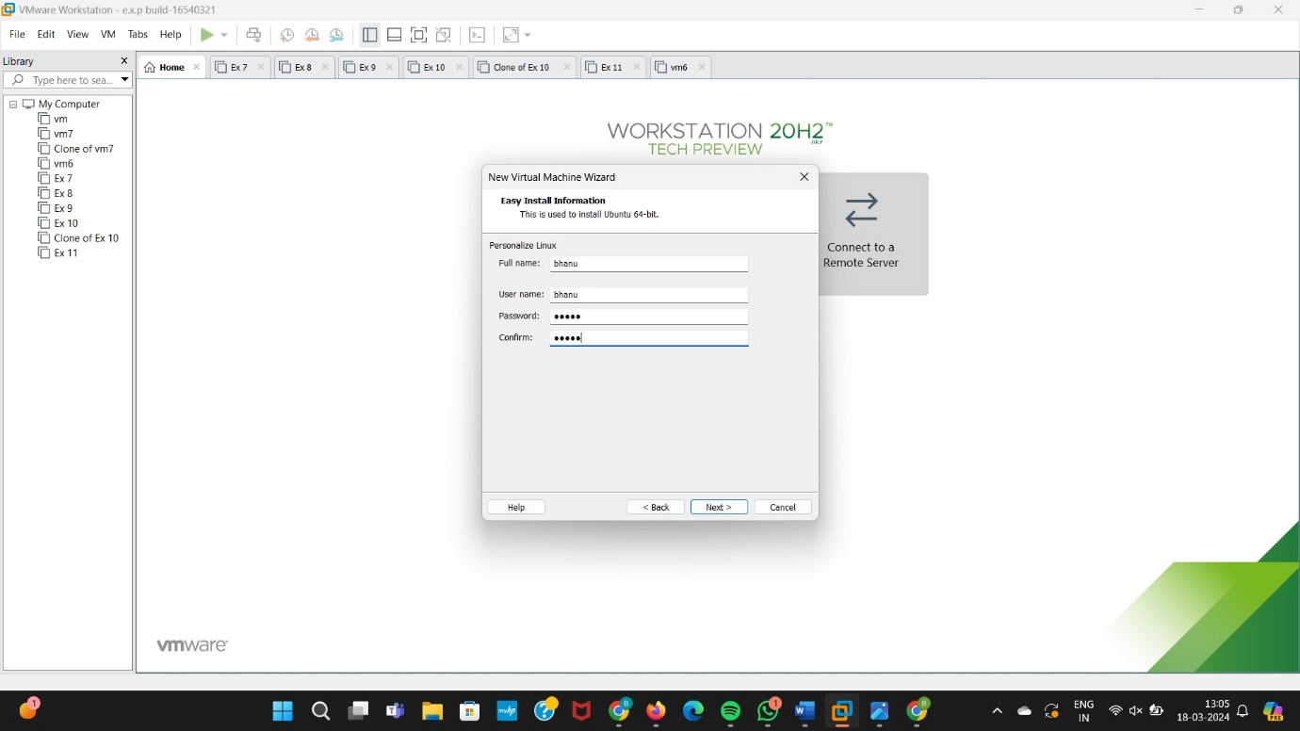

Step 4: Give virtual Machine Name.

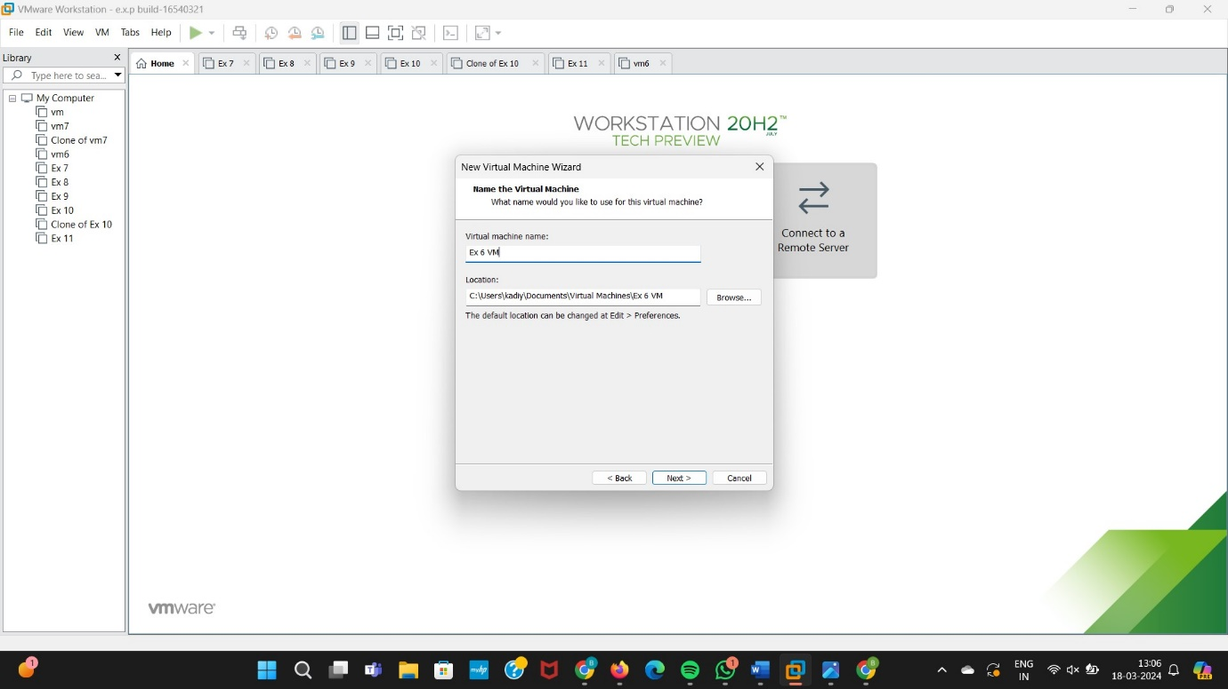

Step 5: Select Single File Option.

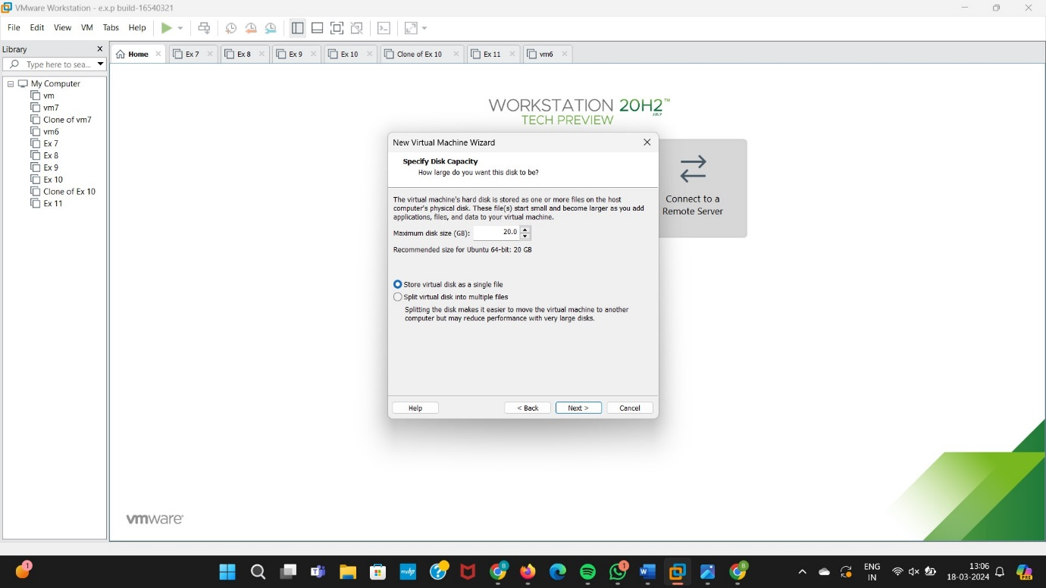

Step 6: Click On Power On Button.

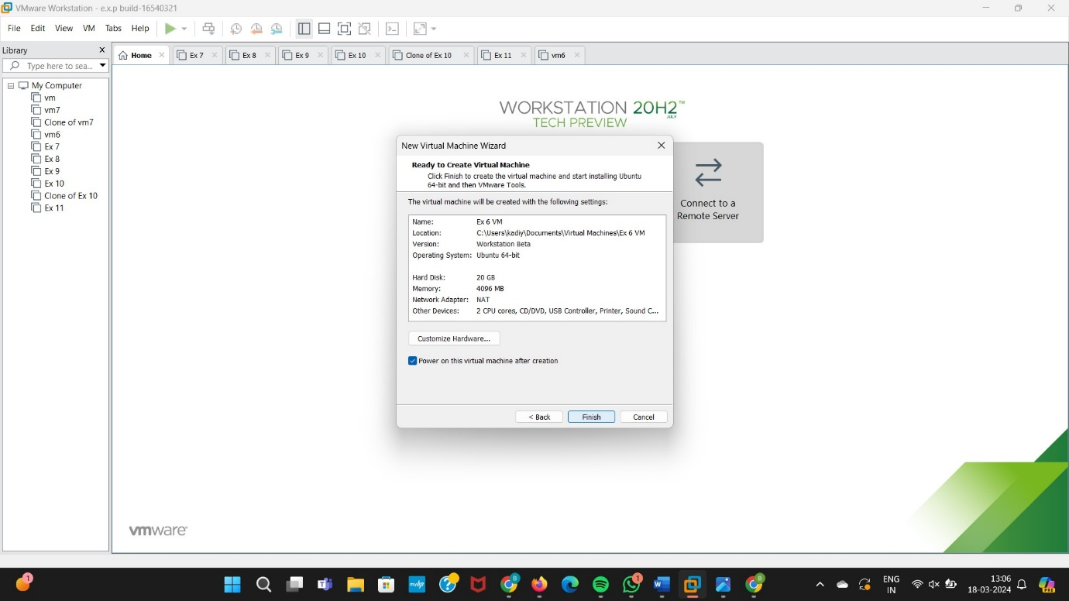

Step 7: final Output.

